***iPlanner***

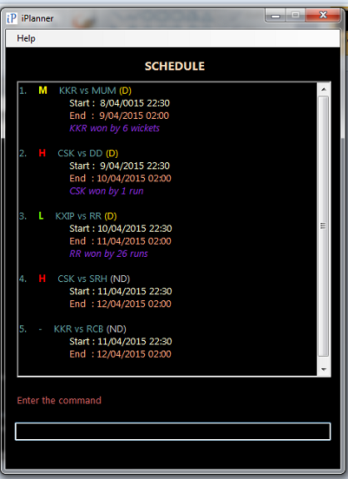

**Supervisor:** Huang Da **Extra Feature:** Automated Testing

|  |  |  |  |  |
| --- | --- | --- | --- | --- |
| C:\Users\HP\Desktop\Semester 4\CS2103 Software Engineering\Profile Picture.jpg | C:\Users\HP\Desktop\Semester 4\CS2103 Software Engineering\Project\Profile - Lee Joon Fai.JPG | ***https://lh5.googleusercontent.com/EfoECgOx8Eww5GvYGyMJkbJcR0iNNBodKoEbiLFTTSiu7T5vCD-6mLILABvVqGWJmc3V8t00s6WgwckKq4flrIG9MogWkha0zBrLNN1vGPBn4LEkP-OCwBBsNZn-9CvvrUY*** | C:\Users\HP\Desktop\Semester 4\CS2103 Software Engineering\Project\Profile - Ng Chon Beng.jpg | C:\Users\HP\Desktop\Semester 4\CS2103 Software Engineering\Project\Profile - Shri Kishen Rajendran.png |
| Andy Soh Wei Zhi | Lee Joon Fai | Yu Youngbin | Ng Chon Beng | Shri Kishen Rajendran |
| Documentation  *Code Quality* | Integration  *Documentation* | **Team Lead**  Scheduling*  *Testing* | Testing  *Integration* | Code Quality  *Scheduling\** |

* Role includes scheduling, tracking, and ensuring adherence of deliverables to deadlines.

# iPlanner User Guide

Welcome to iPlanner – planning and scheduling at your fingertips!

iPlanner is a light and user-friendly task managing software, targeted at the busy individual who requires an efficient way of managing tasks on a desktop or a laptop PC, even when offline. This quick-start guide will bring you through the features provided by iPlanner, everything at your fingertips!

## The User Interface

iPlanner’s user interface is geared towards providing users with fast, understandable, and easily-understood feedback. Control of iPlanner is achieved entirely through the keyboard, and the entering of commands to iPlanner is easy to pick up.

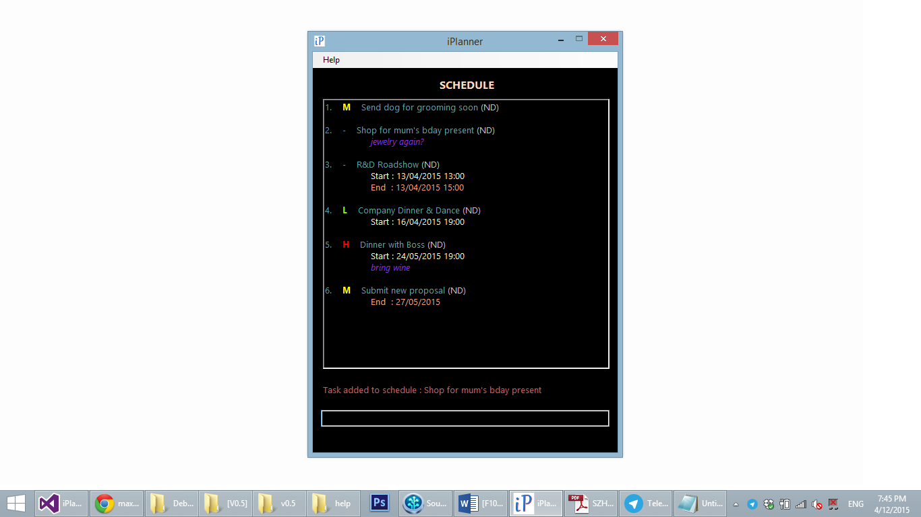

The image above shows how items are displayed in iPlanner. An item has up to six fields for information storage, namely Name, Description, Start Time, End Time, Priority, and Completion. The different fields have also been colour-coded to ensure easy recognizing of elements that are important (e.g. High priority items).

## How Commands Work

iPlanner supports entering multiple relevant commands in the same line. For example, entering:

*add Boss’s birthday party -start 15/03/2015 1300 -end 15/03/2015 1430 -desc 24 Kent Ridge Park, buy present -priority H*

adds a new event, titled “Boss’s birthday party” from 15 March, 1pm to 15 March, 2:30pm, with additional information specified by the user – including location (Kent Ridge Park) and a task to do (buy a present). Additionally, the event is marked as high priority.

### Main Commands

Main input commands:

* add - Add a new item into iPlanner
* del/delete - Remove an item from iPlanner
* edit - Edit the field(s) of an item in iPlanner
* done/undone - Marks an item as done/undone

Main display commands:

* search - Search for a keyword/phrase within the items in iPlanner
* sort - Sort the items on display according to date/name/priority
* view - View only items meeting the condition (high priority, range of dates, all, etc.)

Other main commands:

* clear - Removes all currently-displayed items from iPlanner
* undo - Undo the last undo-able action (add/delete/edit/clear)
* exit - Exits iPlanner

### Sub-Commands

Input sub-commands: The following commands can be used after the ‘*add’* or ‘*edit’* commands to configure the fields of the item being added/edited.

* -desc - Configure item description
* -start/-date - Configure item start date/time
* -end/-due - Configure item end date/time
* -priority - Configure item priority
* -remove/-rmv - Remove a field from the item (only for ‘*edit’*)

Furthermore, in the case where you accidentally type in more than one space between commands and texts, the programme will still be able to recognise the input.

## Add New Item

Create a new item by entering *add <name of item> followed by the sub-command(s)* in the user interface.

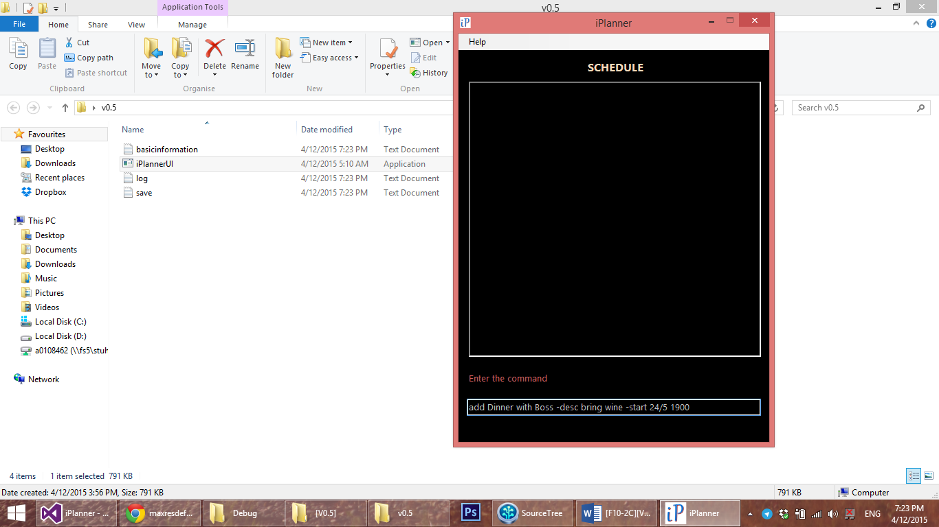

## Edit Item

Edit an existing item by entering *edit <display index of task to be edited> followed by sub-command(s) of item entity to be edited* in the user interface.

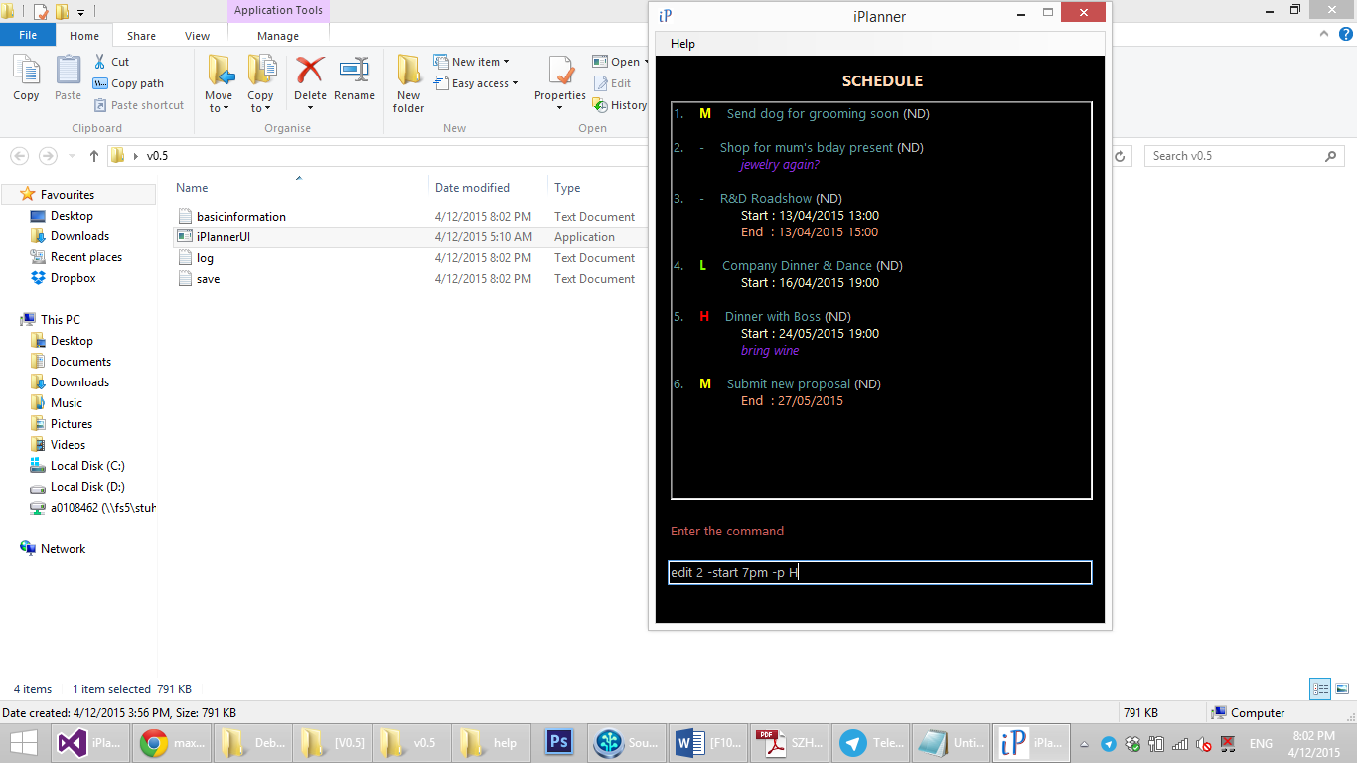

## Delete Item

Delete an existing task by entering *delete <display index of task to be deleted>* or *del <display index of task to be deleted>* in the user interface.

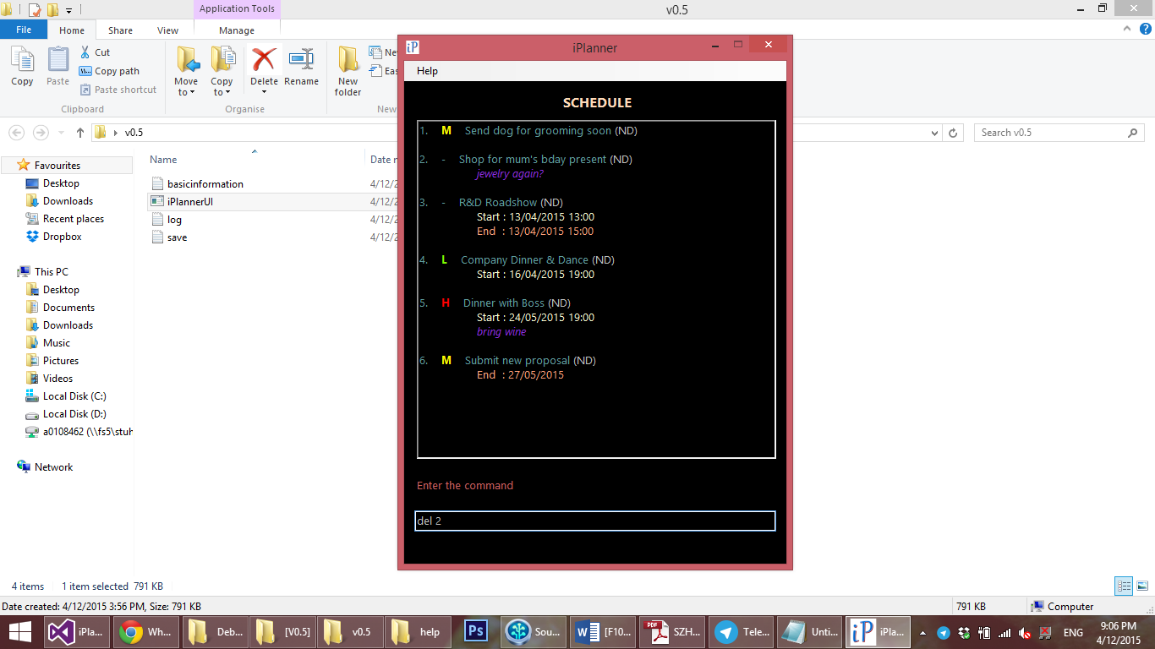

## Assign Timings – *start/date* and *end/due*

In iPlanner, items are categorized into Events (with specific start and end dates/times), Deadlines (with specific due dates/times) and Tasks (without specific dates/times attached). When adding a new item or editing an existing one,

1. Specify start time by entering *-start <dd/mm/yy hhmm>* or -date *<dd/mm/yy hhmm>*
2. Specify end time by entering -*end <dd/mm/yy hhmm> or* -*due <dd/mm/yy hhmm>*

### Flexible date and time formats

iPlanner also supports the input of date and time in flexible formats. A list of supported formats and examples are listed below.

#### Date & Time variations

* 27/12/2015, 17:00 *<date>, <time>*
* 17:00, 27/12/2015 *<time>, <date>*
* 27/12/2015 *<date>* only
* 17:00 *<time>* only, date is set as current date

#### Date variations

* 27/12/2015 *<dd/mm/yyyy>*
* 27 December 2015 *<dd MonthName yyyy>*
* 27 Dec 2015 *<dd ShortMonthName yyyy>*
* 27/12 *<dd/mm>*, year is set as current year
* 27 December *<dd MonthName>*, year is set as current year
* 27 Dec *<dd ShortMonthName>*, year is set as current year

#### Time variations

* 17:00 or 1700 *<hh:mm>* or *<hhmm>* (24 hour format)
* 5:00pm or 500pm *<hh:mm>am/pm* or *<hhmm>am/pm* (12 or 24 hour format)
* 5pm *<hh>am/pm* (12 or 24 hour format)

## Adding Descriptions – *description/desc*

When adding a new item or editing an existing one, additional details or descriptions of the items can also be added by entering *-description <description>* or *-desc <description>* in the user interface after a main input command (add or edit). This may include the location of the event, *e.g. Singapore Flyer*, and other relevant details, *e.g. bring a rose, wear a bowtie*. Note that <*description>* will take on the user’s input until the end of the command line or the beginning of a different sub-command.

## Assign Priority – *priority/p*

When adding a new item or editing an existing one, assign priority to an item by entering *-priority <priority level>* or *-p <priority level>* in the user interface after a main input command (add or edit). Note that priority can only take on the values of low, medium, or high, and <*priority level>* in the user interface can be entered as *low*, *medium* or *high* or *L*, *M*, or *H*.

## Remove Item Field – *remove/rmv*

While editing an item, you can choose to erase the information in the description, start time, end time, and priority fields.

* Remove Description – Remove only the item description by entering *-remove description/desc* or *-rmv description/desc* in the user interface.
* Remove Start Time – Remove only the item start time by entering *-remove start* or *-rmv start* in the user interface.
* Remove End Time – Remove only the item end time by entering *-remove end* or *-rmv end* in the user interface.
* Remove Start and End Times – Remove both the start and end times by entering *-remove date* or -*rmv date* in the user interface.

## Mark Done/Undone – *done* and *undone*

You can mark an item as “Done” by entering *done <task index of task completed>*. User can mark an item as “Not Done” by entering *undone < task index of task completed >*.

## Undo Previous Action – *undo*

Undo the previous undo-able action by entering *undo* into the command line interface. Only add, delete, edit and clear commands are undo-able.

## Search – *search*

Search for an existing item by entering *search <keywords>* in the user interface. Note that *<keywords>* will take on the user’s input until the end of the word, and only results that match the entire string, will be returned.

Multiple strings may be searched by including a '+' in between two words to be searched. For example, *search <keyword1>+<keyword2>+<keyword3>*

## Sort Items – *sort*

The items may be sorted by name, date, priority, completion and update order.

* Sort by Date – The default arrangement of events/deadlines is chronologically, with the earliest ones displayed first, i.e. an event on 4 Jan 2015 will appear before an event on 14 Feb 2015. Tasks (without timestamps) will appear at the beginning. Revert to this arrangement by entering *sort date* in the user interface.
* Sort by Name – Sort items by their names by entering *sort name* in the user interface.
* Sort by Last Update – Sort items in the sequence that they have been updated by entering *sort update* in the user interface.
* Sort by Priority – Sort items in order of priority by entering *sort priority* (or *sort p*) in the user interface. High-priority items will appear first, followed by medium-priority ones, followed by low-priority ones. Items without priority indicators will appear last.
* Sort by Completion – Sort items in order of completion by entering *sort done* in the user interface*.* Items that are not completed are displayed first, followed by items that are completed.

## View Items – *view*

The items may be filtered according to date range, priority, and completion.

* View All – All items in the Schedule can be viewed by entering *view all* in the user interface.
* View Range of Dates – Items between two dates can be viewed by entering *view <date1> <date2>* in the user interface. Events starting, ending, or spanning between that time period and deadlines on that day will be returned.
* View by Priority – View only high-priority, medium-priority, or low-priority items by entering *view High* (or *view H*), *view Medium* (or *view M*), *view Low* (or *view L*) respectively into the command line interface.
* View by Completion – View only items that have been done or that have yet to be done by entering *view done* or *view undone* respectively into the command line interface.

## Storage – *save*

When the program is executed for the first time, the schedule is stored, by default, in the same folder as the executable file.

* Change Save Directory – The save directory can be changed by entering *save <new directory to be saved>* in the user interface.

## Help Menu

A comprehensive help menu detailing all the commands supported by iPlanner and variations of the input format can be called from within iPlanner.

* View Help Menu – View the list of commands supported, their specifications, and syntax by pressing *Alt,* followed by *Enter* in the user interface. The help menu can be scrolled through using the arrow keys and Enter button.

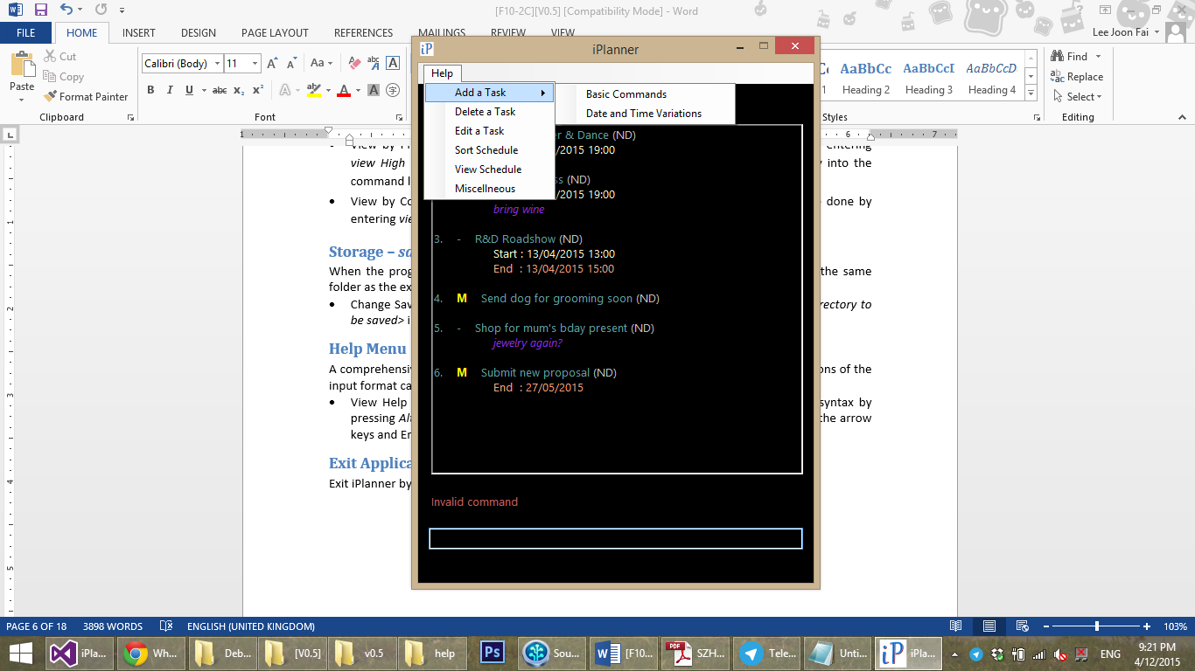

## Exit Application

Exit iPlanner by entering *exit* in the user interface.

# iPlanner Developer Guide

## 1 Introduction

Welcome to the developer guide written for new developers who may be interested in contributing to the development of iPlanner. This guide covers the conventions, recommended tools, as well as the architectural design of the product; it should provide you with the required knowledge to start contributing to iPlanner.

iPlanner aims to be a lightweight, yet functional and efficient to-do list manager software, and the original developers would appreciate it if you keep the above characteristics in mind when expanding this project.

## 2 System Requirements

This project is developed with C++ 11, with the UI using the .NET framework, and the preferred Integrated Development Environment (IDE) is Visual Studio 2013. However, you may use any IDE of your choice, especially if you are already very much more familiar with another IDE. If you do choose your own IDE, please make sure that it supports working with Visual Studio projects seamlessly. In particular, please ensure that you leave no traces of using a different IDE and refrain from committing IDE-specific files into the repository.

The version control system used is Git, and you may pull from our GitHub repository, located at <https://github.com/cs2103jan2015-f10-2c/main>, with any Git client. Our preferred Git client is SourceTree developed by Atlassian, but other clients you are familiar with would work as well. Once done, open iPlanner.sln to begin coding.

## 3 Architecture

Architecture-wise, iPlanner is a relatively simple software, consisting of four main components, the Graphic User Interface (GUI), Logic, Parser, and Storage. GUI shares an association with Logic, while Logic shares associations with Parser and Storage. Additionally, the GUI, Logic and Storage components also share a dependency on the Item and DateTime classes. The relationship between the different components is illustrated in the architecture diagram below:

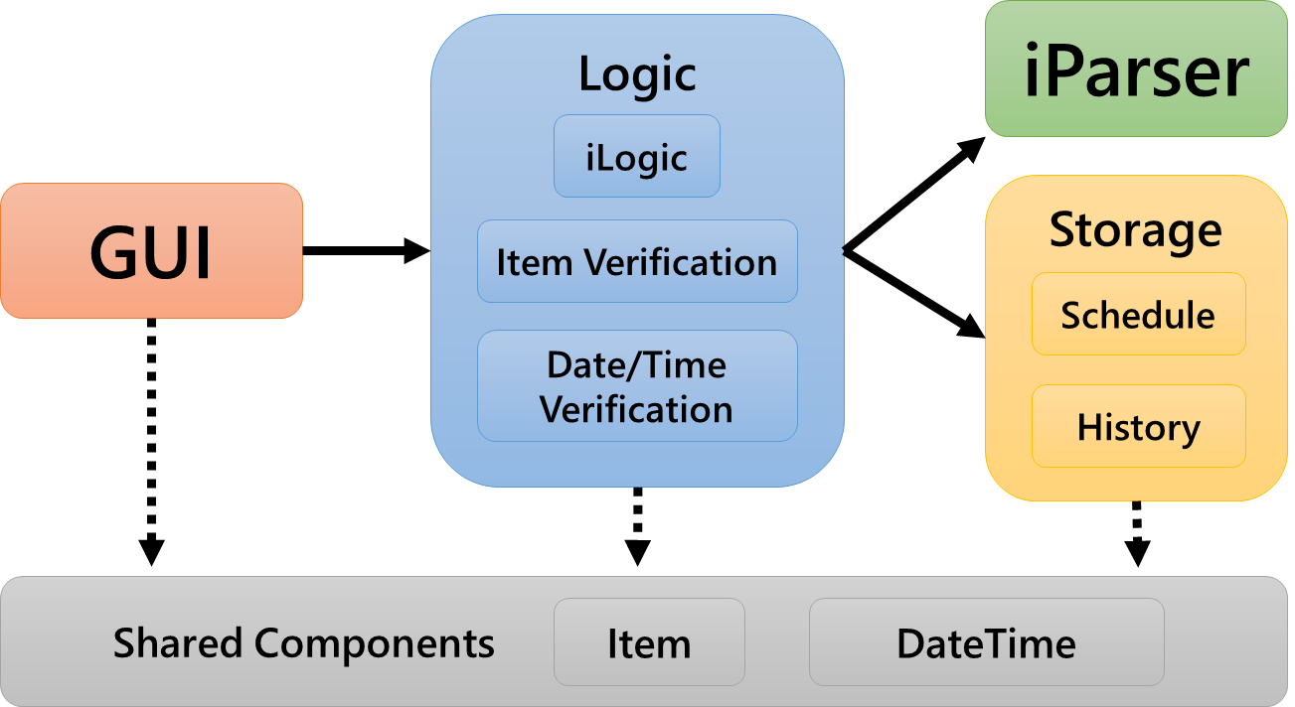

## 4 Component Introduction & Basic Workflow

**GUI:** The GUI is the “entry” and “exit” point of the entire program, also known as a “main”. When the user inputs a command, the GUI starts a propagation of actions deeper into Logic, and subsequently, Parser and Storage. GUI then refreshes the display for the user, and provides him/her with a feedback message and an updated schedule.

**Logic:** The Logic component takes the raw user input that it receives from GUI, and passes it to Parser for conversion into a form that is more easily interpreted by Logic. Running through the list of instructions received from Parser, Logic checks for errors in the user input and executes the required instructions, passing information to Storage where required. It finally returns GUI with a feedback message and an updated schedule for display to the user.

**Parser:** Upon receiving the raw user input from Logic, Parser interprets it and constructs a list of instructions for Logic to execute.

**Storage:** Storage is responsible for the record-keeping of iPlanner. This includes keeping track of all the items in the iPlanner schedule, organising the items in the schedule that has to be displayed to the user, and handling the undo functionality of iPlanner.

### 4.1 Activity Diagram

**(ACTIVITY DIAGRAM & EXPLANATION)**

### 4.2 Sequence Diagrams

The activity diagram in the previous section should have given you a rough idea of how the internal components of iPlanner interact. The following sequence diagrams illustrating some general use cases aim to give you a clearer mental picture of how the various components invoke and propagate API calls to other components in specific use cases.

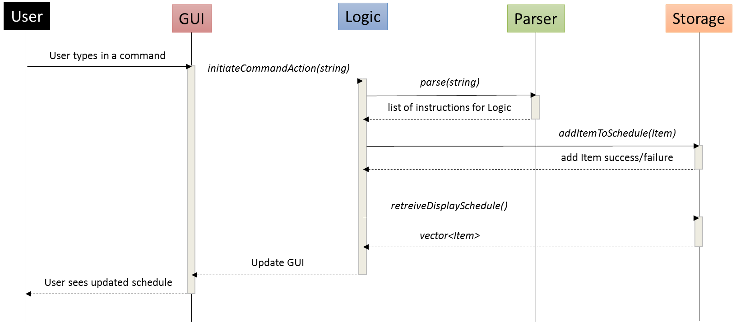

Sequence for adding an item:

1. When the user types in a command, GUI will pass the raw user input as a string to Logic.
2. Logic passes the string on to Parser, who converts the user input into a list of instructions for Logic to execute, in this case, the adding of an item.
3. Running through the list of instructions, Logic creates a new Item with all the fields filled in as specified by the user. Upon reaching the end of the list, Logic does a final check to verify that the fields within the Item are valid inputs, before passing the newly-created Item to Storage for addition into the schedule.
4. Storage stores the Item into a vector in the Schedule sub-component, and saves both the command and the Item into the History sub-component. It then indicates if the addition was a success or a failure.
5. After addition of the Item, Logic calls Storage again and retrieves a copy of the updated schedule for display to the user.
6. Finally, Logic passes the updated schedule on to GUI, which displays the schedule in an accessible and easily-understood format to the user.

**(SEQUENCE DIAGRAM FOR EDIT ITEM)**

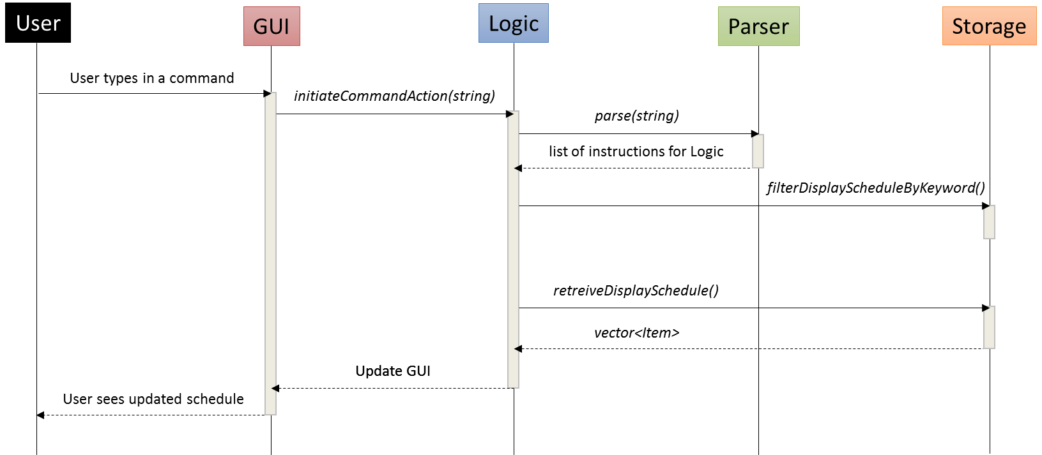

Sequence for searching via a keyword:

1. When the user types in a command, GUI will pass the raw user input as a string to Logic.
2. Logic passes the string on to Parser, who converts the user input into a list of instructions for Logic to execute, in this case, the searching for a keyword.
3. Logic instructs Storage to filter the schedule by, preparing to show the user only the Items containing the search term. If multiple search terms are provided by the user, Logic will repeatedly instruct Storage to filter the schedule.
4. After the filter(s), Logic calls Storage again to retrieve a copy of the updated schedule to display to the user.

**(SEQUENCE DIAGRAM FOR SORTING SCHEDULE)**

## 5 iPlanner Components

### 5.1 GUI

**(COMPONENT DIAGRAM OF GUI)**

#### 5.1.1 Package Overview

#### 5.1.2 Policies

#### 5.1.3 Extensibility

### 5.2 Logic

|  |
| --- |
| **Logic** |
| - _logicSchedule : Schedule  - _logicParser : iParser  - _nextItemID : unsigned int  - _scheduleSize : unsigned int  - _directoryToBeSaved : string  - _fileNameToBeSaved : string  - _currentSorting : string  - _currentFilter : string  - _keywordVec : vector<string>  - _startEndTime : START_END_TIME  - _logicLogger : Log |
| +initiateCommandAction(string) : MESSAGE_AND_SCHEDULE  +getParseInfo(iParser,string) : list<COMMAND_AND_TEXT  +addTask(list<COMMAND_AND_TEXT>) : string  +deleteTask(unsigned int) : string  +sortTask() : string  +filterTask(string) : string  +resetAndGetDisplayVector() : vector<string>  +getErrorList(itemVerification) : string  +changeSavingDirectory(string) : string  +modifyItem(list<COMMAND_AND_TEXT>,Item*) : string |

|  |
| --- |
| **Schedule** |
| - _schedule : vector<Item>  - _scheduleHistory : History |
| + addItem(Item) : unsigned int  +deleteItem(unsigned int) : Item  + retrieveSchedule( ) : vector<Item>&  + getSizeOfSchedule() : unsigned int  + findVectorIndexGivenItemID(unsigned int);  + retrieveScheduleFilteredBy…(char) : const vector<Item>&  + retrieveScheduleBy…() : vector<Item>& |

|  |
| --- |
| **ItemVerification** |
| - _ItemObjectToVeryfy : Item  - _nextID : unsigned int |
| ItemVerification(Item, unsigned int); |

|  |
| --- |
| **Parser** |
| -_parseInfo : ParseInfo  -_inputs : list<string> |
| + parse(string):parseInfo |

The Logic component determines and initiates appropriate functions to be called. In particular, it handles the following operations:

* Calling for a parser and interpreting parsed information
* Initiating and executing storage functions such as add, edit, delete etc. depending on the command given by the user
* Retrieving display vector by various sorting and filtering methods, as the user specified.
* Retrieving item from schedule and modifying item parts
* Verifying the validity of each item components
* Reading data from save file and writing data on to the file
* Passing display message and display vector to GUI

#### 5.2.1 Package Overview

Logic.Logic: Interacts with parser, storage and GUI and controls the change in the storage or display method specified by the user.

Logic.ItemVerification: Provides a validity check of an item that is created or edited.

Logic.DateTimeVerification: Provides a validity check of the DateTime component of an item that is created or edited.

#### 5.2.2 Policies

Façade Pattern: This pattern is used to restrict access of other components to the internal details in the Storage component.

Command Pattern: This is used in Logic Class. Logic component only invokes appropriate functions for the command given and receives a message of success or failure of the command.

#### 5.2.3 Extensibility

Allowing more flexible commands given by the user:

To allow variable commands or modifiers such as “tomorrow” or “monday”, you will need to include a function that interprets those flexi commands and convert it into our appropriate DateTime object.

Implementing detection method over the save text file corruption:

To detect the corruption of the save file, you need to introduce isValidNumberofLines of the saved data. Moreover, you will need to go on and check line by line whether the data in each line represents valid item parts.

### 5.3 Parser

**(COMPONENT DIAGRAM OF PARSER)**

#### 5.3.1 Package Overview

#### 5.3.2 Policies

#### 5.3.3 Extensibility

### 5.4 Storage

**(COMPONENT DIAGRAM OF STORAGE)**

#### The Storage component supports Create, Update, and Delete operations, as well as a search feature, a sort feature and an undo feature. In particular, it handles the following operations:

* Storing a temporary copy of each Item present in the storage files
* Creating, updating, and deleting tasks
* Searching for items with a user-specified keyword
* Filtering items by a given attribute – priority, completion status, date
* Sorting items by a given attribute – priority, completion status, date, name, last update
* Undoing commands executed during the run

#### 5.4.1 Package Overview

Storage.Schedule: Provides all the storage methods that will be called by the Logic components, as well as the relevant tests and supporting functions.

Storage.History: Provides all the methods and data members for the implementation of the undo feature.

#### 5.4.2 Policies

Façade Pattern: This pattern is used to restrict access of other components to the internal details in the Storage component.

Command Pattern: This is used in Logic Class. Logic component only invokes appropriate functions for the command given and receives a message of success or failure of the command.

#### 5.4.3 Extensibility

Implementing new methods to search for/filter Items:

To change the manner in which Items are searched, you need to modify existing or introduce additional filterByAttribute and isMatchingAttribute methods. Moreover, you will need to modify existing or introduce additional public retrieveDisplayScheduleFilteredByAttribute methods.

Implementing new methods to sort Item:

To implement new sorting methods, you need to modify existing or introduce is…Than methods. Moreover, you would need to modify existing or introduce additional public retrieveDisplayScheduleByAttribute methods.

Increasing coverage of undo functionality

To allow the undo feature to cover more commands, you need to introduce new command members into the addCommand and undoLastCommand methods in the History class. Alternatively, new stacks and their corresponding methods can be implemented where appropriate.

### 5.5 Shared Components

#### 4.5.1 Item Class

**(CLASS DIAGRAM OF ITEM CLASS)**

#### 4.5.2 DateTime Class

**(CLASS DIAGRAM OF DATETIME CLASS)**

## 5 Testing

## // EVERYTHING BELOW THIS LINE IS FROM V0.2

## User Interface

A basic graphic user interface is implemented. The User interface passes the command entered to Logic which processes the command entered by the user. Logic returns a vector of Items to be displayed and the outcome of the command as an outcome string. The vector of Items is displayed as the Schedule and the outcome of the command is displayed to the user.

The User Interface also shows the list of commands that the user can write, with their syntax, for the user's reference.

## Logic

Logic calls for a parser to get command. It executes basic functions like add, delete and edit depending on *parseInfo* given by the parser. Upon receiving *parseInfo*, logic calls *ItemVerification* to check whether the parsed item is valid to execute certain function. And finally, if the item is verified, logic is given access to schedule and modify it appropriately.

For now, logic is granted to access schedule and item and to make changes directly. However, from V0.2 onwards, logic will only be able to pass the address or pointer to *Schedule* and only *Schedule* will make the necessary adjustments.

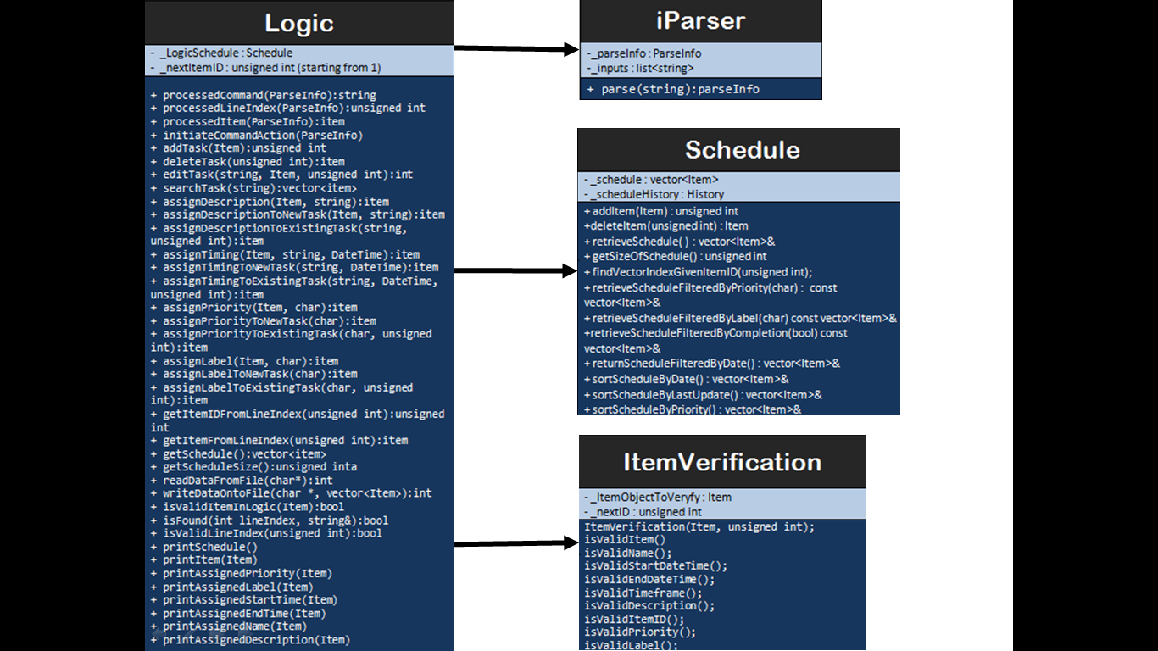

## Parser

Parser receives user input passed as a string data type and parser’s job is to split the user input into the respective commands and texts. Each user input is identified by the token “::”. It is to be noted that the strings split must contain a command but is not necessary accompanied with a text. With each split strings, the parser does a check in the command type and adds the data into *ParseInfo* class attribute.

As the *Parser* class is only required to accept a string data type and return the split information to *Logic*, all functions will be set as private functions with only one function, parse, accessible by *Logic*.

For future development, it will be better for *Parser* to return a list of commands and texts to *Logic*. The list will contain string data types which have been interpreted from the user input. This list of string will allow *Logic* to identify what function to execute.

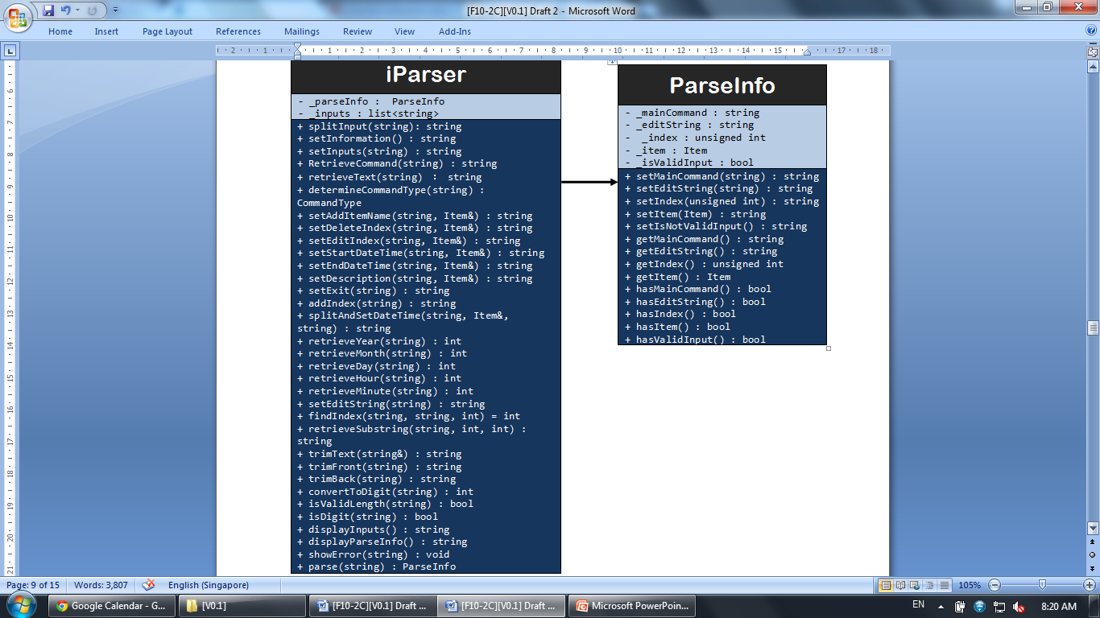

## Storage

Storage is currently implemented in the most basic and straightforward method – declaring and calling objects of a certain class. Each of the currently implemented sub-components – *Schedule*, *Item*, and *dateTime*, has the basic setters (used to assign values during *add* and *edit* functions) and getters (used extensively in *display* and *edit* functions). *Schedule* is slightly more functional with certain types of sorting implemented.

However, moving forward, it is important to implement storage as via pointers to objects, and in order to implement OO fully, logic will only pass values/pointers/objects to *Schedule*, and will not directly access the *Item* or *dateTime* objects via the getters (pass by reference). Local copies will be passed via the getter methods.

For the Storage component, test-driven development has been employed in most parts (exception to Schedule). Current tests are fairly comprehensive, although more efficient methods should be written in future to better compare between class objects (overload of Boolean == and !=, for example). This would allow better and less time-consuming usage of *Assert::AreEqual (... , ...)*.

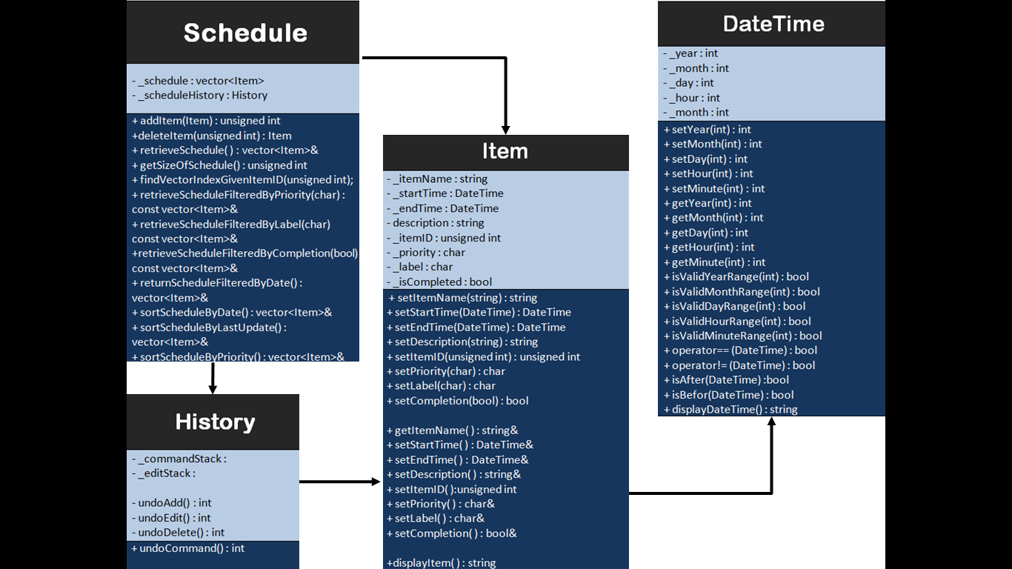

# Appendix A: User Stories. As a user, ...

## [Likely]

|  |  |  |
| --- | --- | --- |
| **ID** | **I can … (i.e. Functionality)** | **so that I … (i.e. Value)** |
| addTask | add a task by name of task only | can record tasks that I want to do a certain day or some day |
| editTask | edit a task by changing details of an already created task | make changes to the details of the task should there be any |
| removeTask | remove a task that had been added earlier | delete a task that is no longer required to be done |
| rescheduleTask | reschedule a task by changing the deadline or time of an already created task | make changes should there be any |
| undoLastAction | undo a single action which was previously done (e.g. add/ remove/ reschedule etc) | do not have to delete and remake the whole schedule one more time |
| specifyDeadline  specifyTimedTask | specify a deadline or time for a task should there be any | can keep track of the important deadline or time |
| clearTasks | clear some or all tasks | do not have to clear them one by one |
| addToArchive | archive tasks which are done or marked as complete | can view them in the future should there be a need to |
| markAsComplete | mark or unmark a task as complete | know what is done / not done and can prioritise my tasks |
| chooseSaveFolder | specify where he wants the data .txt file to be saved | can access it on file-sharing software like Dropbox |
| viewTasks | view upcoming tasks | can have a clearer understanding of my tasks at hand |
| searchTask | search for task(s) using keywords | can filter out the task(s) that I am searching for |
| labelItem | can label tasks into categories | can have an understand which category the tasks belong to |
| addSubTask | can add a daughter task to a parent task | know what tasks are to be done which belongs to the same task |
| addDescription | can add description to a task | do not forget what the task is about should the task name be ambiguous |
| assignPriority | assign priority to a task | know what are the more urgent tasks at hand |
| recurringTasks  [chosen extra feature] | set recurring tasks | do not have to add them over and over again |

## [Unlikely]

|  |  |  |
| --- | --- | --- |
| **ID** | **I can … (i.e. Functionality)** | **so that I … (i.e. Value)** |
| executeHotKey | can make use of hot keys (e.g. ctrl + z) | execute any actions faster |
| notifyClash | should be informed of clashes in timings of scheduled tasks | can plan what to do with the clashes |
| changeView | can filter my tasks in views which i want to see (e.g. category, date, priority etc) | can have a clearer understanding of my tasks at hand |
| setReminder | set reminder to my task | will be informed of the task’s at the time of reminder which was set |
| viewFreeTime | can view my available timeslots on certain day(s) | can make plans on free timings should there be a need |
| viewHelp | can view help document | have an idea how to use the application |

# Appendix B: Non-Functional Requirements

## Desktop

iPlanner will work on a desktop or laptop without network or Internet connection. It is not a mobile application or cloud-based application.

## Windows

iPlanner will work on Windows 7 or Windows Vista OS, and on both 32 bit and 64 bit personal computers.

## Standalone

iPlanner works as a standalone software; it is not a plug-in to another software. However, extensions might be available in later versions to maintain compatibility and exporting of data with other programs or other existing software.

## Non-Installation

iPlanner works without requiring an installer.

## Command Line Interface

Command Line Interface is the primary mode of input, and a basic graphic user interface is used to display the output. There is no need to use the mouse for any point-and-click functions.

## Data Storage

Data storage is done via text files created when the program is run. Text files will be human-editable, and users are able to manipulate the task list by editing the data file.

## Object-Oriented Programming

Most of the iPlanner will follow the object-oriented programming paradigm.

# Appendix C: Product Survey

|  |
| --- |
| **Product:** **Remember The Milk**  **Documented by:** **Lee Joon Fai**  **Strengths:**   * Easy syncing between smartphone app and desktop interface * Adding of tasks and assigning details done very conveniently within one command line * Sort and filter tasks according to labels and priority * Maintains record of completed tasks * Option for app to send automated email reminders * Very flexible and customisable search system * Geo-tagging of tasks is available * User can add notes to tasks along the way * Allows flexible postponement of tasks * Easy undo-ing of accidental actions * Can share to-do list with other users of the app   **Weaknesses:**   * No calendar view, hence difficult for user to visualize longer-term tasks * No option for adding floating tasks i.e. all tasks must have a deadline * Smartphone app interface is very different from desktop interface. The switch between devices is not intuitive enough * The software has remained pretty stagnant over the years, updates are not frequent |
| **Product:** **wunderlist**  **Documented by:** **Yu Young Bin**  **Strengths:**   * It is easy to post on facebook immediately since it is connected to facebook account. * It has simple and easy user interface. * User can customize the background picture. * User gets notification on important events. * User can categorise the events and to-do lists. * User can search for a certain event. * User can even post pictures related to the event. * User can sort the events in accordance with the alphabetical order or deadlines etc. * It is easy to create, delete, and move any events. * User can print out the to-do list directly from the application * User can e-mail the to-do list directly from the application   **Weaknesses:**   * It does not seem quite necessary to create an account and login to use this application. * There is no user guide for the new users to get familiarized with the product. * There is no calendar view. It is difficult to visualize the sequence of the upcoming events. * When a user accidentally presses the tick-box on the to-do list, the event just disappears. |
| **Product: Microsoft Outlook Calendar**  **Documented by: Ng Chon Beng**  **Strengths:**   * Can add item into calendar view * Able to reschedule and delete item * Able to view calendar offline * Easy calendar view to see schedule * Has a reminder function * Has recurring function * Able to categorise items with different colours * Able to change view (e.g. daily, weekly, monthly) * Has a search function * Has weather forecast (provided there is internet connection) * Able to share calendar with others   **Weaknesses:**   * Unable to see timing at default view * Unable to mark as done nor archive action which are done * Unable to quick launch software using shortcut key * Unable to add item with no specific due date * Takes multiple actions to add an item |
| **Product: Google Calendar**  **Documented by: Shri Kishen Rajendran**  **Strengths:**   * It has a structured and organised look. * It can be viewed in the format of a day, week or month. * It allows differentiating tasks by the usage of different colours for different events. * It has a search function which can also search for files on the user’s Google Drive. * User is a given a reminder of a task half an hour before a scheduled event. * User is allowed to sync other calendar(.ics) files. * User can have a task list where additional sub tasks can also be added under tasks. * User can specify a deadline for a task.   **Weaknesses:**   * It does not work without internet connection and a Google account. * It can be difficult to read if there are too many appointments. * The interface is more useful for planning events than tasks. * No feature to indicate if an event is complete or not. |
| **Product: ColorNote**  **Documented by: Andy Soh Wei Zhi**  **Strengths:**   * Two types of notes are available – free-style text notes and lists * Notes are simple and intuitive; they only have three properties – title, content, colour * Sorting of the notes can be by time modified and colour * Notes can be viewed as a list (with titles only), list (with details), grid, or a large grid, giving users flexibility to decide what works best for them. * Notes can be backed-up on cloud storage. * List-styled notes can be dragged easily to re-order items within the notes * Sticky notes that can appear on home screen for user convenience * Notes can be edited directly by double-tapping them, again simple and intuitive. * Accidental deletion of notes is prevented (delete and permanently delete options). * Notes can be assigned to days via a calendar. * Time reminders can be set for each note. * Notes can be locked with password to ensure privacy.   **Weaknesses:**   * Only platform supported is Android (no iOS or PC). * Notes are not file compatible with other programmes, i.e. cannot export notes to a Microsoft Excel compatible file or Google Calendar. * Pictures, photographs, and drawings are not supported. * High customizability comes with a trade-off – lack of automaton, e.g. manually marking certain items/lines as completed. |